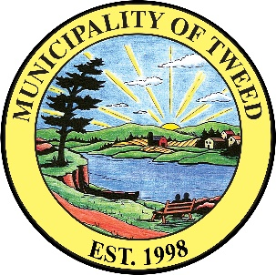

Municipality of Tweed
Accessibility Feedback Form

Thank you for visiting the Municipality of Tweed. We value all of our customers and strive to meet everyone’s needs.

- Please tell us the date and time of your visit:

- Did we respond to your customer service needs today? (Circle one)

Yes

No (Please explain below)

- Was our customer service provided to you in an accessible manner? (Circle one)

Yes

No (Please explain below)

- Did you have any problems accessing our goods and services? (Circle one)

Yes (Please explain below)

Somewhat (Please explain below)

No

- Please add any other comments you may have: (Circle one)

- Contact information (optional):

The Municipality of Tweed thanks you for your input!

